Project Development Phase
Model Performance Test

Date | 01 October 2026
Team ID | SWTID-2026-2158
Project Name | Auto Ticket Classification using Flow Designer
Maximum Marks | 10 Marks

Model Performance Testing:
Project team shall fill the following information in model performance testing template.
S.No. | Parameter | Values | Screenshot
 | Model Summary | ServiceNow Flow Designer automation for school IT ticket management. Incident Workflow stores structured ticket data, while the flow automatically classifies issues and sends an email notification. | 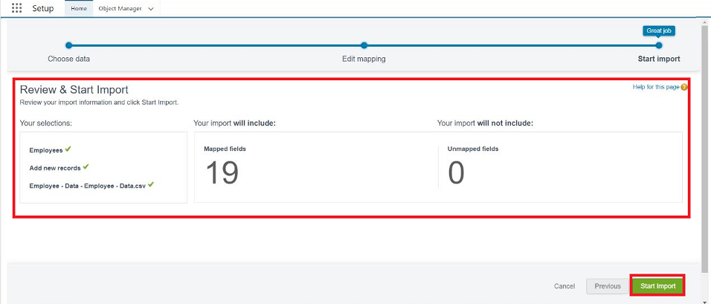
 | Accuracy | Training Accuracy - N/A  Validation Accuracy - N/A  This is rule-based automation, not a trained model. | - 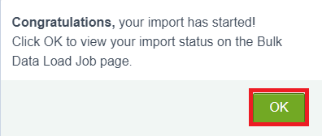
3. | Confidence Score (Only Yolo Projects) | Not Applicable - YOLO/object detection is not used. The system identifies predefined keywords in ticket descriptions. | 